**DAILY ONLINE ACTIVITIES SUMMARY**

|  |  |  |  |  |  |  |  |
| --- | --- | --- | --- | --- | --- | --- | --- |
| **Date:** | **4/06/2020** | | | | **Name:** | **Samrin Banu** | |
| **Sem & Sec** | **8th B** | | | | **USN:** | **4AL16CS082** | |
| Online Test Summary | | | | | | | |
| **Subject** | | **SMS** | | | | | |
| **Max. Marks** | | **--60** | | **Score** | | **--45** | |
| Certification Course Summary | | | | | | | |
| **Course** | **Amazon web service** | | | | | | |
| **Certificate Provider** | | | **Aws** | **Duration** | | | **3 hrs** |
| Coding Challenges | | | | | | | |
| **Problem Statement:** 1) C Program to Print Pyramids and Patterns | | | | | | | |
| **Status: Solved** | | | | | | | |
| **Uploaded the report in Github** | | | | **YES** | | | |
| **If yes Repository name** | | | | **Samrinbanu** | | | |
| **Uploaded the report in slack** | | | | **YES** | | | |

Online test detail:

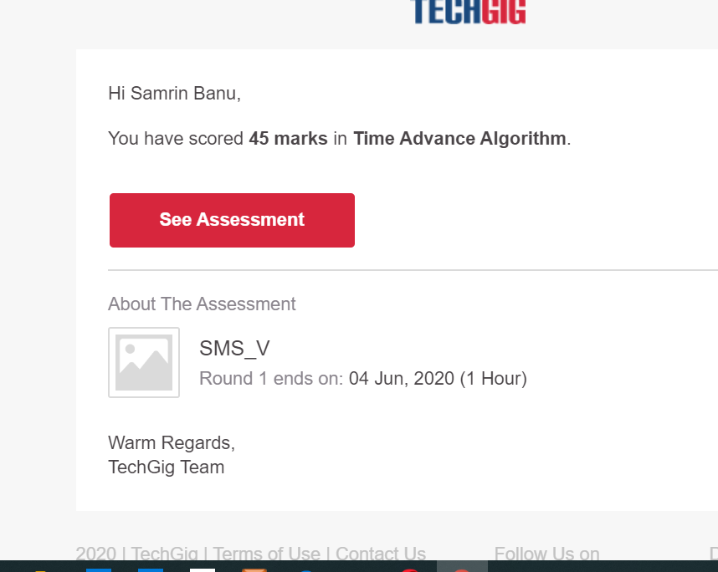

**Certification Course Details:**

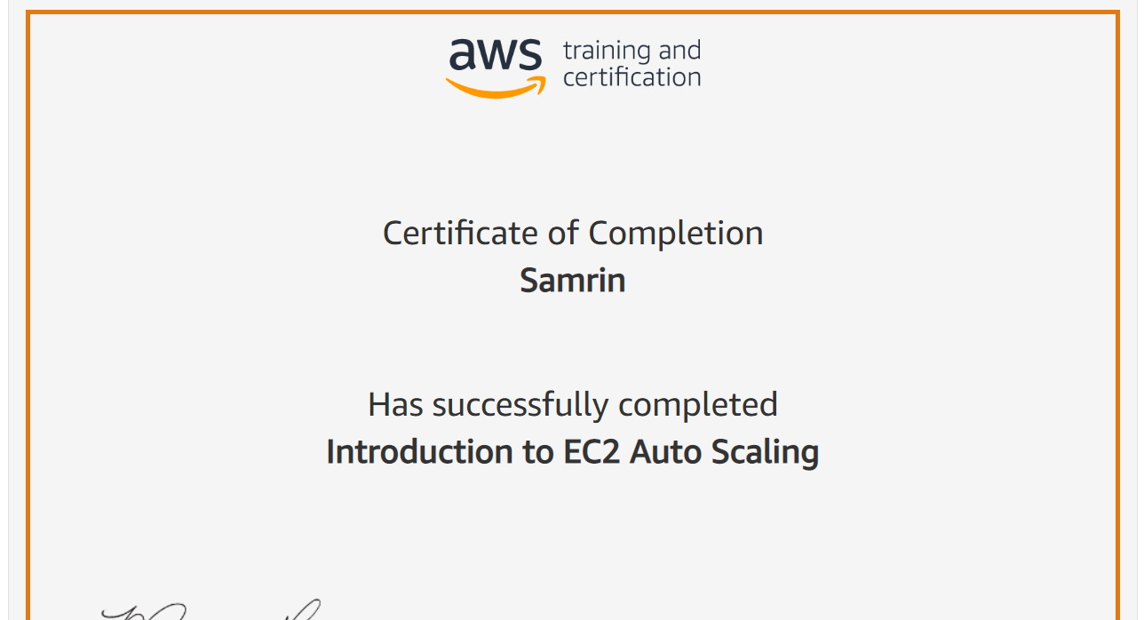

# CODE:

Program no:1

#include <stdio.h>

int main() {

int i, j, rows;

printf("Enter the number of rows: ");

scanf("%d", &rows);

for (i = 1; i <= rows; ++i) {

for (j = 1; j <= i; ++j) {

printf("* ");

}

printf("\n");

}

return 0;

}